# Operation Checks

The following are operation checks need to be completed at per stated freqency to ensure that the system is 100% operational and running optimally.

|  |  |  |
| --- | --- | --- |
| Operation Checks | | |
| **Freqency** | **Tasks** | **Explanation** |
| Daily | Backup MIIS/ILM/FIM databases | Because your IDM data is a critical asset to your organization, it is important to back up your IDM database regularly. It is recommended to configure the database to use the Full recovery model. |
| Daily | SQL Heath Check | It is also important to monitor your MS SQL Server on a regular basis to assure optimum performance and reliability. |
| Daily | Review Run History | Under the operations tab in Identity Manager all latest Run History events will be listed. These should have run on specified time slots and have a successful status. All events with erros should be investigated. |
| Weekly | Monitor operating system | Need to ensure operating system is running and preforming optimally. Check event logs and general operating check e.g. Disk space, memory and CPU utilization. |
| Weekly | Monitor Run History maintance | There is a scheduled task that clears out all run history older than 45 days. Run history data can grow very large affecting performance and must be cleared out. Check to see that this process runs successfully. |
| Montly | Back up the encryption keys. | Should you need to restore your MIIS/ ILM/FIM environment you would need to have your encryption keys handy. |
| Montly | Backup the entire MIIS/ILM/FIM Installation | This way you could recovery your server should it become currrupt or in a hard drive crash situation. |
| Quarterly | Perform a test recovery of your data in a test environment by using your production backups. | It is also strongly recommended that you test your backup and restore procedures before an emergency occurs |
| Quarterly | Review your backup procedures and amend as necessary | It is essential to keep your backup procedure up to date. |
| As needed | Use Export Management Agent to backup management agents whenever you change management agent rules. | After you use Export Management Agent, you can then use the Import Management Agent command to import a specific version of the individual management agent. |
| As needed | Populate the displayName attribute in the metaverse to make search results easier to identify. | When listing objects by using Metaverse Search, MIIS/ILM/FIM returns results identified by the displayName attribute. If the displayName attribute is not populated, the search results are identified by the globally unique identifier (GUID). |
| As needed | Use Preview to test synchronizations and troubleshoot errors | You can use Preview to troubleshoot synchronization errors due to join failures or schema violations. |

# Common Problems

Troubleshooting MIIS / ILM / FIM Related Error Codes

When working with MIIS, ILM or FIM in relation to Imports, Exports or Synchronizations you might get errors. Some of the errors are easier to understand than others. Understanding the errors allows you to resolve the issue much faster.

**Sources:**

* <http://msdn.microsoft.com/en-us/library/ms695993(VS.85).aspx>
* <http://msdn.microsoft.com/en-us/library/ms696554(VS.85).aspx>
* <http://msdn.microsoft.com/en-us/library/ms695995(VS.85).aspx>
* <http://msdn.microsoft.com/en-us/library/ms699322.aspx>

### CONNECTION RELATED ERRORS:

| Error Value | Description |
| --- | --- |
| successful-connection | Successful connection to the connected directory. |
| failed-connection | Connection to the connected directory has failed for a reason other than authentication. Generally, the connected directory error element will be present to assist in troubleshooting. |
| dropped-connection | The connection between the management agent and the connected directory no longer exists. The management agent will try to reconnect to the connected directory in many cases. Generally, the connected directory error element will be present to assist in troubleshooting. |
| failed-authentication | Authentication is not possible using the supplied credentials. |
| failed-permission | Insufficient rights to access a container in the connected directory. This error is only expected for LDAP management agents which search different connected directory containers. Generally the connected directory error element will be present to assist in troubleshooting and the error literal will indicate the name of the container where the problem occurred. |
| failed-search | A container or table search failed with an unexpected error. Generally, the connected directory error element will be present to assist in troubleshooting and the error literal will indicate the name of the container it had trouble searching. |
| warning-no-watermark | The management agent cannot read the watermark when doing a full import. This error is only expected for the management agent for Sun ONE Directory Server 5.1 (formerly iPlanet Directory Server) when the initial management agent configuration was completed when the connected directory had change log enabled. Later when the connected directory change log is turned off, if the management agent configuration is not updated, this warning will occur when a full import is done. |

### DISCOVERY RELATED ERRORS:

| Error Value | Description |
| --- | --- |
| missing-change-type | Returned during a delta import run by a file management agent, database management agent, or the management agent for Sun ONE Directory Server 4.1x and 5.x (formerly iPlanet Directory Server) and Netscape Directory Server 4.1 and 6.01 when the change type column value (for example, add, modify, delete) is not present. |
| invalid-change-type | Returned either during a LDIF full import, or during a delta import run by a file management agent, database management agent, or the management agent for Sun ONE Directory Server 4.1x and 5.x (formerly iPlanet Directory Server) and Netscape Directory Server 4.1 and 6.01 when the change type column value doesn't match the list of valid changes types. |
| multi-valued-change-type | Returned during a delta import run by a file management agent or the management agent for Sun ONE Directory Server 4.1x and 5.x (formerly iPlanet Directory Server) and Netscape Directory Server 4.1 and 6.01 when more than one value for the change type is present. |
| need-full-object | Returned during a delta import run of a file management agent or when resuming from a file management agent. It indicates the management agent has submitted a modification on an object which cannot be located in the connector space. The synchronization engine is requesting the current values of all attributes on the object. Since this is an import from a file, that information is not available. A full import run will take care of this problem. |
| missing-dn | Returned for file management agents (LDIF, DSML, or flat file with configured distinguished name attribute) when there is no distinguished name value. This is also returned in the case of a corrupted Sun ONE Directory Server 5.1 change log where the distinguished name attribute is missing. It indicates the management agent could read the element and parse it, but there was no distinguished name value for the object. |
| dn-not-ldap-conformant | Returned when a management agent for LDAP, LDIF, or DSML, or a flat file with a configured distinguished name attribute reports a distinguished name value that does not conform to the LDAP specification. |
| invalid-dn | Returned when an management agent reports that a distinguished name does not meet an Identity Integration Server constraint, which includes: |
| One or more characters that are not allowed by Identity Integration Server |
| An empty RDN |
| An RDN exceeding the maximum for Identity Integration Server |
| The number of hierarchy levels of the distinguished name exceeded the maximum for Identity Integration Server |
| missing-anchor-component | Returned by a file management agent, database management agent or iPlanet 4.0 management agent when the anchor could not be constructed because one or more anchor construction rule attributes did not have values. |
| multi-valued-anchor-component | Returned by the management agent for Sun ONE Directory Server 4.1x and 5.x (formerly iPlanet Directory Server) and Netscape Directory Server 4.1 and 6.01 indicating the management agent could not construct the anchor because an anchor construction rule attribute had more than one value. |
| anchor-too-long | Returned by the database management agent, files management agent or the management agent for Sun ONE Directory Server 4.1x and 5.x (formerly iPlanet Directory Server) and Netscape Directory Server 4.1 and 6.01 indicating the management agent anchor construction produced an anchor which exceeded the maximum size limit for Microsoft Identity Integration Server 2003. |
| duplicate-object | Returned on full imports by either a file management agent or a database management agent. It indicates an object with the same anchor has already been reported to the synchronization engine during this run. |
| missing-object-class | Returned by either a file management agent (DSML, LDIF, or a flat file management agent with a configured object class attribute) or in the case of a corrupted Sun ONE Directory Server 4.1x and 5.x (formerly iPlanet Directory Server) and Netscape Directory Server 4.1 and 6.01 change log. This indicates that the management agent could not read a value for the object class attribute. |
| missing-object-type | Returned when doing a resume of import from a corrupted drop file. |
| Note This error should not be encountered during normal operation. |
| unmappable-object-type | Returned by a file management agent when it reads an object which has a set of object class values that cannot be matched to any of the prefix mappings. |
| parse-error | Returned by the management agent for Sun ONE Directory Server 4.1x and 5.x (formerly iPlanet Directory Server) and Netscape Directory Server 4.1 and 6.01 in delta mode and by a file management agent when it cannot parse an entry. The <entry-number> element (and in most cases <line-number> and <column-number>) will be present to help locate the error. The <attribute-name> element may be present. The Sun ONE Directory Server 5.1 management agent will terminate the run when this is encountered. The file management agent will log the discovery error and continue. |
| read-error | Returned by a call based management agent when there is a generic error reading a particular object. This generally causes termination of the run. The connected directory error element will be present to help troubleshoot the problem. |
| staging-error | Returned by most management agents, including the management agent for Sun ONE Directory Server 4.1x and 5.x (formerly iPlanet Directory Server) and Netscape Directory Server 4.1 and 6.01. It indicates the synchronization engine could not stage the delta in the connector space. The server will create an event log giving information about the problem that can be used for troubleshooting. Most management agents will continue the import run when the error is logged, but Sun ONE Directory Server 5.1 delta runs will stop because gaps in the change log processing could be cause an inconsistent state in the connector space. |
| Note: This error should not be encountered during normal operation. |
| invalid-reference-value | Returned by a management agent indicating a distinguished name does not meet Microsoft Identity Integration Server 2003 constraints, which include: |
| One or more characters that are not allowed by Microsoft Identity Integration Server 2003 |
| An empty RDN |
| An RDN exceeding the maximum for Microsoft Identity Integration Server 2003 |
| The number of hierarchy levels of the distinguished name exceeded the maximum for Microsoft Identity Integration Server 2003 |
| invalid-modification-type | Returned during a delta import on an LDIF management agent under two conditions: when a value modification type is not one of the standard LDIF modification types; when there is a non-replace LDIF delta on objectclass, such as: "add: objectclass" or "delete:objectclass" |
| conflicting-modification-types | Returned during a delta import on an LDIF management agent under two conditions: when there are different attribute level modification types in the same record (in this case the attribute name which produced the conflicting types is reported); when multiple replace LDIF objectclass deltas are seen in the same file, such as: |
| replace: objectclass |
| objectclass: group |
| - |
| replace: objectclass |
| objectclass: user |
| multi-single-mismatch | Returned by a file management agent when the management agent reports more than one value add or more than one value delete for an attribute that is defined in Microsoft Identity Integration Server 2003 as being a single valued attribute. This error may indicate that the connected directory schema stored with Microsoft Identity Integration Server 2003 was incorrectly specified (file management agents) or out of date with the current connected directory schema. |
| invalid-attribute-value | Returned by a called-based management agent when an attribute value is read that does not conform to the attribute type declared in schema. |
| invalid-base64-value | Returned by the LDIF management agent, DSML management agent or Sun ONE Directory Server 5.1 management agent when they fail to parse a base64-encoded value. |
| invalid-numeric-value | Returned by a file management agent or an LDAP management agent when they are unable to parse a numeric value. |
| invalid-boolean-value | Returned by a file management agent or an LDAP management agent when they are unable to parse a Boolean value. |
| reference-value-not-ldap-conformant | Returned by an LDAP management agent, LDIF management agent, DSML management agent or flat file (with configured distinguished name attribute) indicating a distinguished name value does not conform to the LDAP specification. |
| unsupported-value-type | Returned by an LDIF management agent when a file reference is specified for an attribute which is not of the string attribute type. This is also returned by the DSML management agent when a URI reference is specified for an attribute which is not of the string attribute type. |
| If a file reference needs to be interpreted, set up a scripted import attribute flow and parse the value to discover the file reference the string points to. |
| locking-error-needs-retry | Returned by a management agent when another management agent is trying to synchronize the same connector spaces object. To resolve this error, rerun the management agent a second time and error should not reoccur. |
| Note This is an error for runs involving full import or full synchronization, and a warning in the following cases: |
| A delta-import to a file |
| A delta-import stage to the connector space |
| A delta-import, delta synchronization |
| A delta synchronization from the connector space |
| A delta synchronization from a file |

### IMPORT AND SYNCHRONIZATION RELATED ERRORS:

| Error Value | Description |
| --- | --- |
| exported-change-not-reimported | Changes exported to a management agent were not reconfirmed during this import management agent run. A user or a system process operating outside Microsoft Identity Integration Server 2003 has changed the data in the connected directory in a way that conflicts with the export attribute flow rules configured for Microsoft Identity Integration Server 2003. Alternately, this value indicates a configuration problem where the export attribute flow rule is trying to flow a value to a connected directory object, but the connected directory automatically resets the value to something different without reporting an error to the management agent. The [<change-not-reimported>](http://msdn.microsoft.com/en-us/library/ms694676(VS.85).aspx) element indicates which changes were not reconfirmed. |
| extension-dll-exception | The rules extension caused an exception. |
| extension-dll-crash | The process executing the rules extension unexpectedly terminated. This error can only occur when an a rule extension is being executed out-of-process. A possible cause for this error value is the rules extension is calling code that causes an access violation. |
| extension-dll-timeout | The rules extension contains an extension timeout value and the call to the extension exceeds this timeout value. Note that when you are debugging the process that is executing the extension, timeouts are not enforced. |
| extension-projection-object-type-not-set | The implementation of the [**IMASynchronization.ShouldProjectToMV**](http://msdn.microsoft.com/en-us/library/ms696517(VS.85).aspx) method in the rules extension does not specify the metaverse object type. |
| extension-projection-invalid-object-type | The implementation of the [**IMASynchronization.ShouldProjectToMV**](http://msdn.microsoft.com/en-us/library/ms696517(VS.85).aspx) method in the rules extension sets the value of the outbound metaverse object type to a value that is not listed in Metaverse Designer of Identity Manager. Check that the method uses one of the specified object type values. |
| extension-join-resolution-invalid-object-type | The implementation of the [**IMASynchronization.ResolveJoinSearch**](http://msdn.microsoft.com/en-us/library/ms696516(VS.85).aspx) method in the rules extension sets the value of the outbound metaverse object type to a value that is not listed in Metaverse Designer of Identity Manager. Check that the method sets the value of the outbound metaverse object type to one of the listed object type values. |
| extension-join-resolution-index-out-of-bounds | The implementation of the [**IMASynchronization.ResolveJoinSearch**](http://msdn.microsoft.com/en-us/library/ms696516(VS.85).aspx) method in the rules extension set an index value that is less than zero or greater than the number of metaverse entry objects. |
| extension-provisioning-call-limit-reached | The Provision method is called more than 10 times during the synchronization of a single object. The Provision method can be called more than once if the customer logic in the Provision method deprovisions an object and there is resulting attribute recall that causes a change to the metaverse object resulting in a new call to Provision and so on. Identity Integration Server limits the number of such Provision calls to 10 calls in order to stop possible infinite provisioning notes. |
| extension-deprovisioning-invalid-result | The implementation of the [**IMASynchronization.Deprovision**](http://msdn.microsoft.com/en-us/library/ms696510(VS.85).aspx) method returns an invalid [**DeprovisionAction**](http://msdn.microsoft.com/en-us/library/ms695485(VS.85).aspx) enumeration value. Verify that the method returns a valid value. |
| extension-entry-point-not-implemented | The rules extension throws an [**EntryPointNotImplementedException**](http://msdn.microsoft.com/en-us/library/ms695988(VS.85).aspx) exception. |
| extension-unexpected-attribute-value | The rules extension throws an [**UnexpectedDataException**](http://msdn.microsoft.com/en-us/library/ms698802(VS.85).aspx) exception. |
| flow-multi-values-to-single-value | When an import or export attribute flow rule configured in Identity Manager attempts to flow a multi-valued attribute to an attribute with a single value. This value only occurs in flow rules configured in Identity Manager. If the flow rule uses a rules extension that flows a multi-valued attribute to a single value attribute, the [**TooManyValuesException**](http://msdn.microsoft.com/en-us/library/ms698775(VS.85).aspx) exception is thrown. |
| cs-attribute-type-mismatch | The type of the imported attribute does not match the attribute type specified in the management agent schema. For more information about synchronizing the management agent schema with the connected data source schema, see "Refresh a management agent schema" in Microsoft Identity Integration Server 2003 help. |
| join-object-id-must-be-single-valued | The data source attribute value used to join a metaverse object through a join rule specified in the properties of a management agent in Identity Manager contains more than one value. The data source attribute value used in the join rule can only contain a single value. |
| dn-index-out-of-bounds | The distinguished name component index value used in an import attribute flow configured in the properties of a management agent in Identity Manager is larger than the number of components in the distinguished name of the source object. |
| connector-filter-rule-violation | A connector object becomes a filtered disconnector object as a result of a connector-filter configuration during provisioning or export attribute flow. This value will not occur on explicit connector objects. |
| unsupported-container-delete | The management agent is attempting to delete a container object during deprovisioning. The management agents included in Microsoft Identity Integration Server 2003 cannot delete container objects. |
| ambiguous-import-flow-from-multiple-connectors | An import attribute flow rule defined in Identity Manager is for a management agent with multiple connector objects joined to a metaverse object. To import attributes through a management agent with multiple connectors to a metaverse object, use a rules extension to define the flow rules rather than configuring a join rule in the properties of a management agent. |
| ambiguous-export-flow-to-single-valued-attribute | The export flow rule configured in the properties for a management agent in Identity Manager is attempting to flow values from a reference attribute of a metaverse object to a single connector object in the connector space but the metaverse object is joined to multiple connector objects in the connector space |
| cannot-parse-dn-component | The distinguished name mapping rule specified in the properties of a management agent in Identity Manager cannot flow an improperly formatted distinguished name component to the metaverse object. |
| cannot-parse-object-id | The string value used to search for a metaverse object in a join rule specified in the properties of a management agent in Identity Manager is not in the correct globally-unique identifier (GUID) format. The GUID format is "{nnnnnnnn-nnnn-nnnn-nnnn-nnnnnnnnnnnn}" where "n" is a hexadecimal number. |
| unexported-container-rename | The implementation of the [**IMVSynchronization.Provision**](http://msdn.microsoft.com/en-us/library/ms696527(VS.85).aspx) or [**IMASynchronization.Deprovision**](http://msdn.microsoft.com/en-us/library/ms696510(VS.85).aspx) method is attempting to rename a container object with one or more unexported child objects. |
| unique-index-violation | A user is manually setting a unique index number on an attribute in a metaverse table. Do not manually configure the metaverse tables. |
| mv-constraint-violation | The attribute value from the connector space exceeds the length restrictions of the metaverse attribute. |
| locking-error-needs-retry | Returned by a management agent when another management agent is trying to synchronize the same connector spaces object. To resolve this error, rerun the management agent a second time and error should not reoccur.  Note This is an error for runs involving full import or full synchronization, and a warning in the following cases:   * A delta-import to a file * A delta-import stage to the connector space * A delta-import, delta synchronization * A delta synchronization from the connector space * A delta synchronization from a file |
| unexpected-error | An unexpected error occurred during an apply change management agent run. Check the event log for more information. |
| exported-change-not-reimported | Changes exported to a management agent were not reconfirmed during this import management agent run. A user or a system process operating outside Microsoft Identity Integration Server 2003 has changed the data in the connected directory in a way that conflicts with the export attribute flow rules configured for Microsoft Identity Integration Server 2003. Alternately, this value indicates a configuration problem where the export attribute flow rule is trying to flow a value to a connected directory object, but the connected directory automatically resets the value to something different without reporting an error to the management agent. The <change-not-reimported> element indicates which changes were not reconfirmed. |

### EXPORT AND SYNCHRONIZARION RELATED ERRORS:

| Error Value | Cause |
| --- | --- |
| ambiguous-update | The management agent cannot fulfill an update or delete request because the anchor is incorrectly configured or not unique. This error can be returned by SQL and Oracle management agents. If this error is encountered, check the anchor construction rules to ensure that each object has a unique anchor value. |
| anchor-too-long | An attempt is made to construct an anchor that exceeded the maximum size limit for Microsoft Identity Integration Server 2003. This error can be returned by database management agents, file management agents, or the iPlanet 4.0 management agent. |
| cd-error | An error is encountered while attempting to communicate with a connected data source, but there is no specialized error type for this error. This error is accompanied by a <cd-error> element, which contains information that should aid in troubleshooting the cause of the error. |
| cd-existing-object | A request to add an object is exported to the connected data source, but the object is already present in the connected data source. This error can be returned by call-based management agents except for relational database management agents. It is never returned by file management agents. |
| cd-missing-object | A request to modify an object is exported to the connected data source, but the object cannot be found in the connected data source. This error can be returned by call-based management agents, but never by a file management agents. The likely cause of this error is because some person or external process has deleted the object from the connected data source outside Identity Integration Server. |
| certifier-ou-not-configured | An attempt is made to provision out a new user or container (o or ou) and the certifier name you have specified for the "_MMS_Certifier" attribute is not the name of a properly configured certifier container. Each certifier container must be configured using the Identity Integration Server administrative UI before it can be used in provisioning. This error can be returned by the management agent for Lotus Notes. |
| code-page-conversion | An attempt is made to export an attribute value, which is stored in Unicode within the Identity Integration Server, to the code page of the export file, but fails because of conversion errors. This error can be returned by file management agents. |
| constraint-violation | An attempt is made to export an add, modify, or delete request that violates the constraints of a connected data source. This error can be returned by LDAP management agents and database management agents. Violations for LDAP management agents include setting multiple values for a single valued attribute, exceeding field width constraints on string and binary attributes, or exceeding range constraints on numeric attributes. Database management agents can impose a variety of constraints, including those for referential integrity, rules, and constraints that may be defined for their database. |
| dn-attributes-failure | An attempt is made to export an add or modify request that sets a reference value for which there is no corresponding connected data source object. This error can be returned by the Active Directory management agent, Active Directory/Application Mode management agent, and global address list synchronization management agent. The other management agents do not generate an error in this situation—the set is accepted by the connected data source. To correct this error, use the connector space object viewer to determine which of the changes to the reference attributes were not successfully exported. |
| duplicate-anchor | The anchor on a newly provisioned object is not unique. This error can be returned by file management agents, database management agents, or the iPlanet 4.0 management agent. If this error is encountered, check the anchor construction rules to ensure that each object has a unique anchor value. |
| encryption-not-enabled | An attempt is made to set or change the password attribute and the connection that the management agent uses to communicate to the connected data source has not been configured with an appropriate encryption mechanism (128 bit SSL or TLS). This error can be returned by the Active Directory/Application Mode management agent. 128-bit SSL or TLS configuration is a requirement imposed by Active Directory/AM for setting passwords. |
| insufficient-columns | An attempt is made to export an add or modify request to an object and the number of values for a multivalued attribute exceeds the number of columns configured for that attribute's multi-values. This error can be returned by the Fixed Width management agent or Delimited management agent. |
| insufficient-field-width | An attempt is made to export an add or modify request to an object and the value of an attribute exceeds the width of the column. This error can be returned by the Fixed Width management agent. |
| invalid-attribute-value | An attempt is made to flow out an attribute value that contains characters which are not not valid for the connected data source. For example, the attribute values exported to the fixed width, delimited, and AVP file management agents cannot contain CR, LF, or EOF characters. |
| invalid-dn | An attempt is made to export a newly provisioned object or rename an existing object, and the distinguished name is incompatible with the connected data source naming requirements. This error can be returned by LDAP management agents and the Windows NT 4.0 management agent. |
| invalid-provisioning-attribute-value | An attempt is made to export a newly provisioned object, but certain attributes for provisioning set by the customer extension are not valid (such as not in a certain value range). |
| kerberos-no-logon-server | An attempt is made to set or change a password attribute, and the management agent cannot resolve a server for the domain part of the logon credentials. This generally means a NetBIOS or DNS misconfiguration. This error can be returned by the Active Directory management agent or the global address list synchronization management agent. |
| kerberos-time-skew | The password attribute is being set or changed, and the time on the server running Identity Integration Services differs from the time on the Active Directory domain controller by more than five minutes. This error can be returned by the management agent for Active Directory or the management agent for Active Directory global address list (GAL). |
| locking-error-needs-retry | Returned by a management agent when another management agent is trying to synchronize the same connector spaces object. To resolve this error, rerun the management agent a second time and error should not reoccur. |
| missing-anchor-component | An attempt is made to export a newly provisioned object, but an anchor cannot be generated because a value required for constructing the anchor is not available. Possible for reasons for this error are that the attribute was not set at provisioning time (in the case of the iPlanet 4.0 management agent, database management agents, or file management agents) or it cannot be read from the connected data source (Active Directory management agents, the iPlanet 5.0 management agent, and database management agents when the anchor is constructed from an auto-increment column). |
| missing-provisioning-attribute | An attempt is made to export a newly provisioned object, but certain attributes that are required for provisioning a new object have not been set by the customer extension. This error can be returned by the Notes management agent. |
| modify-naming-attribute | An attempt is made to export a request where a naming attribute (such as CN for many object types) is set to a value that conflicts with the RDN value. This error can be returned by LDAP management agents. This error can occur because of a poorly defined export attribute flow rule or an error in the process code that sets initial values on a newly provisioned object. |
| multi-valued-anchor-component | An attempt is made to construct the anchor for a newly provisioned object, but one of the attributes used in constructing the anchor has multiple values. This error can be returned by the iPlanet 4.0 management agent. Attributes used in the anchor construction can be defined to be multivalued in the connected data source schema, but they must only have a single value on the objects in Identity Integration Server. |
| no-export-to-this-object-type | The management agent only allows import of objects of this object type. No export operations are allowed on this type of object. This error is returned by the NT 4.0 management agent if you try to perform provisioning operations or export attribute flow on computer objects. |
| non-existent-parent | An attempt is made to export an add or a rename request but the parent object does not exist in the connected data source. This error can be returned by LDAP management agents. |
| password-policy-violation | The password attribute is set or changed to a value which does not meet the administrator defined password policy of the connected data source. This error can be returned by the Active Directory management agent and global access list directory synchronization management agents. |
| password-set-disallowed | The password encryption is set to either no encryption or less than 128-bit SSL and the administrator has not explicitly made an override to allow password sets. This error can be returned by the Active Directory management agent. |
| permission-issue | An attempt is made to export an add, modify, or delete request and the management agent has insufficient permissions to perform the operation against the connected data source. This error can be returned by LDAP management agents and the NT4.0 management agent. |
| provision-to-secondary-nab | An attempt is made to provision a person or certifier object to a secondary Notes address book. This error can be returned by the Notes management agent. Lotus Notes only allows provisioning contacts to secondary Notes address books. |
| rename-to-existing-dn | An attempt is made to change the distinguished name of the object at the time of export but there is already an object in the connector space with that distinguished name. The distinguished name of an object can be changed on export in two ways:  Database management agents, where the distinguished name is calculated based on the values of the attributes making up the anchor (these values may not be present until the object is exported)  LDAP management agents where the connected data source applies certain normalization rules that cause the distinguished name to change.  In either case, examine how the distinguished name property of the object is created in the provisioning extension. |
| schema-violation | An attempt is made to export an object modification that would add an attribute that is not in the connected data source schema or remove an attribute from an object which is required by the schema. This error can be returned by LDAP management agents. In most cases Identity Integration Server will not allow this error to occur since its rules check the stored copy of the connected data source schema. However, this error can occur if the Identity Integration Server schema is out of date with the connected data source schema. If this error is encountered, use the Identity Manager to refresh the schema stored with the management agent. |
| syntax-violation | An attempt is made to export a request where the value for an attribute violates certain value constraints. This error can be returned by the management agent for LDAP Data Interchange Format (LDIF) files and the management agent for Windows NT 4.0. A typical case of this error is when the value being exported contains a character that is not valid. |
| temporary-certifier-file-creation-failure | An attempt was made to fetch the certifier information for the certifier container specified by the "_MMS_Certifier" attribute and temporarily create a certifier file in the MAData directory of the Notes MA for use by the Notes API. This occurs when a new user or container (o or ou) is provisioned. If this process of creating the certifier file fails for any reason (for example, out of disk space, permissions, etc) this export error is reported. This error can be returned by the Lotus Notes management agent. |
| unexpected-error | An attempt is made to export a change and an unexpected error is encountered. To help troubleshoot this error, examine the event log. This error should not be encountered as part of normal operation and indicates a product malfunction. If you do encounter this error, contact Microsoft Product Support. |
| unexpected-provisioning-attribute | This error is returned when you are exporting a newly provisioned object and certain attributes for provisioning set by the customer extension should not be included because they are incompatible with the values of other provisioning attributes. This error is returned by the Notes management in the following cases:  When you create a contact (_MMS_IDRegType=0) and supply any one of the following attributes:   * _MMS_Certifier * _MMS_OU * _MMS_Password * _MMS_IDStoreType * _MMS_IDPath * MailFile   When you create a U.S. user or International user but do not specify creating an ID file (_MMS_IDStoreType=0), but supply the _MMS_IDPath or MailFile attributes.  When you create an OU (certifier), and supply the _MMS_OU attribute.  When you create an O (certifier), and supply the _MMS_Certifier attribute. |

### WMI PROVIDER RETURN STRINGS:

| Return code/value | Description |
| --- | --- |
| call-failure | An unexpected error occurred.  Check the event log for more information. |
| connection-failure | This error is returned when you have successfully obtained a WMI object, but either the service has been stopped or your security identity has been removed from the security group(s) that have rights to use the WMI interface (administrators, operators, password set, and browse). |

### COMMON TO THE FOLLOWING METHODS, PROPERTIES AND XML ELEMENTS:

* [**MIIS_ManagementAgent.Execute**](http://msdn.microsoft.com/en-us/library/ms697765(VS.85).aspx) method
* [**MIIS_ManagementAgent.RunStatus**](http://msdn.microsoft.com/en-us/library/ms697827(VS.85).aspx) property
* [**MIIS_RunHistory.RunStatus**](http://msdn.microsoft.com/en-us/library/ms697858(VS.85).aspx) property
* [**< step-result >**](http://msdn.microsoft.com/en-us/library/ms698763(VS.85).aspx) element of the [**< run-history >**](http://msdn.microsoft.com/en-us/library/ms698398(VS.85).aspx) XML string

| Return code/value | Description |
| --- | --- |
| completed-discovery-errors | The full import run step stopped and the data was not obsoleted because of discovery errors between the connected directory and the connector space. The next step in the run profile will not run and data will not be obsoleted. If an import run step returned this value, the processing of retries and cleanup of placeholder objects will not be performed. If this string is the value for the **MIIS_ManagementAgent.RunStatus** property, then no run step is currently running but a run step has been run in the past. |
| completed-export-errors | The run step completed with export errors. The next step in the run profile will run. If this string is the value for the **MIIS_ManagementAgent.RunStatus** property, then no run step is currently running but a run step has been run in the past. |
| completed-no-objects | The full import run step found nothing to import. |
| completed-sync-errors | The run step completed with synchronization errors or warnings. The next step in the run profile will run and data will be obsoleted. If this string is the value for the **MIIS_ManagementAgent.RunStatus** property, then no run step is currently running but a run step has been run in the past. |
| completed-transient-objects | The run step completed with objects in the connector space in a transient state. For more information about the transient state, see "The metaverse and the connector space" in the ILM 2007 FP1 Help. The next step in the run profile will run and data will be obsoleted. If this string is the value for the **MIIS_ManagementAgent.RunStatus** property, then no run step is currently running but a run step has been run in the past. |
| completed-warnings | The run step completed with synchronization warnings. The next step in the run profile will run and data will be obsoleted. If this string is the value for the **MIIS_ManagementAgent.RunStatus** property, then no run step is currently running but a run step has been run in the past. |
| completing-obsoletion | The system is in the process of marking objects in the connector space that no longer exist in the connected data source as obsolete. You can see how complete by the value of **in-progress**. |
| completing-referential-updates | The system is in the process of completing its referential updates. You can see how complete by the value of **in-progress**. |
| connection-failure | The server is not running or your credentials were removed from the security groups.  Check that the credentials used is a member of a ILM 2007 FP1 security group. The method can return this string after you obtain the WMI provider object. |
| in-progress | Indicates the percentage of completion for processes that are not yet complete. |
| no-start-bad-ma-configuration | The run step failed to start because the management agent configuration is corrupt. The next step in the run profile will not run and data will not be obsoleted. If an import run step returned this value, the processing of retries and cleanup of placeholder objects will not be performed.  Recreate the management agent to prevent this return value.  If this string is the value for the **MIIS_ManagementAgent.RunStatus** property, then no run step is currently running but a run step has been run in the past. |
| no-start-change-log-not-enabled | The delta import run step failed to start because the change log in the Sun ONE Directory Server 5.1 (formerly iPlanet Directory Server) was not enabled. The next step in the run profile will not run and data will not be obsoleted. If an import run step returned this value, the processing of retries and cleanup of placeholder objects will not be performed.  Enable the change log in the server to prevent this return value. For more information about enabling the change log, see the Sun ONE Directory Server 5.1 documentation.  If this string is the value for the **MIIS_ManagementAgent.RunStatus** property, then no run step is currently running but a run step has been run in the past. |
| no-start-connection | The run step failed to start because of connection problems. The next step in the run profile will not run and data will not be obsoleted. If an import run step returned this value, the processing of retries and cleanup of placeholder objects will not be performed.  Verify that you are connected to the server to prevent this return value.  If this string is the value for the **MIIS_ManagementAgent.RunStatus** property, then no run step is currently running but a run step has been run in the past. |
| no-start-credentials | The run step failed to start because of credential problems. The next step in the run profile will not run and data will not be obsoleted. If an import run step returned this value, the processing of retries and cleanup of placeholder objects will not be performed.  Verify that the credentials used to execute the run profile are members of the appropriate security group. For more information about ILM 2007 FP1 security groups, see "Using security groups" in the Microsoft Identity Integration Server 2003 Help.  If this string is the value for the **MIIS_ManagementAgent.RunStatus** property, then no run step is currently running but a run step has been run in the past. |
| no-start-database-permission | The run step failed to start because the account used does not have permission to access to the database or the table. The next step in the run profile will not run and data will not be obsoleted. If an import run step returned this value, the processing of retries and cleanup of placeholder objects will not be performed.  Verify that the account used to run the management agent has access to the database or table.  If this string is the value for the **MIIS_ManagementAgent.RunStatus** property, then no run step is currently running but a run step has been run in the past. |
| no-start-database-schema-mismatch | The run step failed to start because the configured schema does not match the schema in the connected directory. The next step in the run profile will not run and data will not be obsoleted. If an import run step returned this value, the processing of retries and cleanup of placeholder objects will not be performed.  Verify that the schemas in the connected directory and the configuration match.  If this string is the value for the **MIIS_ManagementAgent.RunStatus** property, then no run step is currently running but a run step has been run in the past. |
| no-start-database-table | The run step failed to start because the management agent is connected to the database but could not access the specified table. The next step in the run profile will not run and data will not be obsoleted. If an import run step returned this value, the processing of retries and cleanup of placeholder objects will not be performed. |
| no-start-delta-step-type-not-configured | The delta import run step failed to start because the management agent is not configured for a delta import. The next step in the run profile will not run and data will not be obsoleted. If an import run step returned this value, the processing of retries and cleanup of placeholder objects will not be performed. |
| no-start-file-access-denied | The run step failed to start because access to the file specified in the **Input file name** text box of **Management agent configuration** in the **Configure Run Profile** dialog box was denied. Verify that you have access to the file.  If this string is the value for the **MIIS_ManagementAgent.RunStatus** property, then no run step is currently running but a run step has been run in the past. |
| no-start-file-code-page | The run step failed to start because the selected code page does not match the file specified in **Template Input File** of the management agent properties. The next step in the run profile will not run and data will not be obsoleted. If an import run step returned this value, the processing of retries and cleanup of placeholder objects will not be performed.  Use the code page that is appropriate for the input file. For more information about specifying the code page, see "Select a template input file" in the ILM 2007 FP1 Help.  If this string is the value for the **MIIS_ManagementAgent.RunStatus** property, then no run step is currently running but a run step has been run in the past. |
| no-start-file-contains-incorrect-step-type | The run step failed to start because the step requires a different type of drop file. For example, the step might require a delta-import drop file but the drop file is from a full-import step.  Verify that you are providing the correct type of drop file. |
| no-start-file-not-found | The run step failed to start because the file specified in **Input file name** text box of **Management agent configuration** in the **Configure Run Profile** dialog box could not be found. The next step in the run profile will not run and data will not be obsoleted. If an import run step returned this value, the processing of retries and cleanup of placeholder objects will not be performed.  Verify the specified input file is in the working folder of the management agent. For more information about specifying the input file used by a run profile step, see "Example: Running a Management Agent With a Specified Run Profile" in the ILM 2007 FP1 Help.  If this string is the value for the **MIIS_ManagementAgent.RunStatus** property, then no run step is currently running but a run step has been run in the past. |
| no-start-file-open | The run step failed because the file specified in **Input file name** text box of **Management agent configuration** in the **Configure Run Profile** dialog box could not be opened. The next step in the run profile will not run and data will not be obsoleted. If an import run step returned this value, the processing of retries and cleanup of placeholder objects will not be performed.  If this string is the value for the **MIIS_ManagementAgent.RunStatus** property, then no run step is currently running but a run step has been run in the past. |
| no-start-file-sharing-violation | The run step failed to start because of a sharing violation on the file specified in **Input file name** text box of **Management agent configuration** in the **Configure Run Profile** dialog box. The next step in the run profile will not run and data will not be obsoleted. If an import run step returned this value, the processing of retries and cleanup of placeholder objects will not be performed.  Verify that ILM 2007 FP1 is the only program that is using this file. If not, close all other programs.  If this string is the value for the **MIIS_ManagementAgent.RunStatus** property, then no run step is currently running but a run step has been run in the past. |
| no-start-full-import-required | The delta import run step failed to start because you first need to complete a full import step. The next step in the run profile will not run and data will not be obsoleted. If an import run step returned this value, the processing of retries and cleanup of placeholder objects will not be performed.  Complete a full import step before starting a delta import to prevent this return value.  If this string is the value for the **MIIS_ManagementAgent.RunStatus** property, then no run step is currently running but a run step has been run in the past. |
| no-start-header-row-mismatch | The import run step stopped because the header row in the file did not match the configured header row.  Make the necessary modifications so that the header row in the file matches the configured header row. |
| no-start-ma | The run step failed to start because of an unknown management agent error. The next step in the run profile will not run and data will not be obsoleted. If an import run step returned this value, the processing of retries and cleanup of placeholder objects will not be performed.  If this string is the value for the **MIIS_ManagementAgent.RunStatus** property, then no run step is currently running but a run step has been run in the past. |
| no-start-no-domain-controller | The run step failed to start because the domain controller could not be contacted by the server. The next step in the run profile will not run and data will not be obsoleted. If an import run step returned this value, the processing of retries and cleanup of placeholder objects will not be performed.  Verify that the domain controller is connected to the network.  If this string is the value for the **MIIS_ManagementAgent.RunStatus** property, then no run step is currently running but a run step has been run in the past. |
| no-start-no-partition-delete | The run step failed to start because domain or naming context has been deleted. The next step in the run profile will not run and data will not be obsoleted. If an import run step returned this value, the processing of retries and cleanup of placeholder objects will not be performed.  Verify that the specified partition still exists.  If this string is the value for the **MIIS_ManagementAgent.RunStatus** property, then no run step is currently running but a run step has been run in the past. |
| no-start-partition-not-configured | The run step failed to start because the required partition is not selected in **Configure Directory Partitions** dialog box of the management agent properties. The next step in the run profile will not run and data will not be obsoleted. If an import run step returned this value, the processing of retries and cleanup of placeholder objects will not be performed.  Verify that the appropriate partition is selected. For more information see "Configure directory partitions" in the ILM 2007 FP1 Help.  If this string is the value for the **MIIS_ManagementAgent.RunStatus** property, then no run step is currently running but a run step has been run in the past. |
| no-start-partition-rename | The run step failed to start because the selected partition in **Configure Directory Partitions** dialog box of the management agent properties has been renamed. Verify that the appropriate partition is selected. For more information, see "Configure directory partitions" in the ILM 2007 FP1 Help.  If this string is the value for the **MIIS_ManagementAgent.RunStatus** property, then no run step is currently running but a run step has been run in the past. |
| no-start-server | The run step failed to start because of an unknown server error. The next step in the run profile will not run and data will not be obsoleted. If an import run step returned this value, the processing of retries and cleanup of placeholder objects will not be performed. |
| no-start-unknown-profile-name | Could not execute management agent because the name of the profile passed as a parameter to the **Execute** call is unknown. |
| stopped-bad-ma-configuration | The run step stopped because of a corrupted management agent configuration. The next step in the run profile will not run and data will not be obsoleted. If an import run step returned this value, the processing of retries and cleanup of placeholder objects will not be performed.  Verify that your management agent is configured correctly. For more information about configuring your management agent, see Configure Management Agents in the ILM 2007 FP1 Help. |
| stopped-change-log-out-of-order | In some cases the Sun ONE Directory Server can write a change log (used for delta imports) with entries which are not numbered sequentially.  To fix this problem, run a full import before doing more delta imports. |
| stopped-code-page-conversion | The import run step stopped because of a code page conversion error. The next step in the run profile will not run and data will not be obsoleted. If an import run step returned this value, the processing of retries and cleanup of placeholder objects will not be performed.  Verify that you are using the appropriate code page for the template input file. For more information about setting the code page, see "Select template input file" in the ILM 2007 FP1 Help.  If this string is the value for the **MIIS_ManagementAgent.RunStatus** property, then no run step is currently running but a run step has been run in the past. |
| stopped-connectivity | The run step stopped because of connectivity loss. The next step in the run profile will not run and data will not be obsoleted. If an import run step returned this value, the processing of retries and cleanup of placeholder objects will not be performed.  Restore connectivity to the server.  If this string is the value for the **MIIS_ManagementAgent.RunStatus** property, then no run step is currently running but a run step has been run in the past. |
| stopped-database-connection-lost | The run step stopped because the server is not connected to the SQL Server database used by the ILM 2007 FP1 server. This value occurs if the server stores the metadirectory on a separate computer that is running SQL Server. The next step in the run profile will not run and data will not be obsoleted. If an import run step returned this value, the processing of retries and cleanup of placeholder objects will not be performed.  Resolve the connection problem. |
| stopped-database-disk-full | The run stopped because the SQL Server database used by the ILM 2007 FP1 server is full. The next step in the run profile will not run and data will not be obsoleted. If an import run step returned this value, the processing of retries and cleanup of placeholder objects will not be performed.  Create some space in the SQL Server database. |
| stopped-deadlocked | The run step stopped because of an internal server deadlock between multiple management agent runs. The next step in the run profile will not run and data will not be obsoleted. If an import run step returned this value, the processing of retries and cleanup of placeholder objects will not be performed.  Resolve the deadlock. |
| stopped-disk-full | The run step stopped because of a full disk. Create space on the disk. The next step in the run profile will not run and data will not be obsoleted. If an import run step returned this value, the processing of retries and cleanup of placeholder objects will not be performed.  Create space on the disk.  If this string is the value for the **MIIS_ManagementAgent.RunStatus** property, then no run step is currently running but a run step has been run in the past. |
| stopped-error-limit | The run step stopped because the run profile reached the error limit. The errors appear in **Synchronization Errors** in Identity Manager. The next step in the run profile will not run and data will not be obsoleted. If an import run step returned this value, the processing of retries and cleanup of placeholder objects will not be performed.  Resolve these errors.  If this string is the value for the **MIIS_ManagementAgent.RunStatus** property, then no run step is currently running but a run step has been run in the past. |
| stopped-export-write | The export run step stopped because of an error writing to the connected directory. The next step in the run profile will not run and data will not be obsoleted. If an import run step returned this value, the processing of retries and cleanup of placeholder objects will not be performed.  Verify that the server is connected to the network and has write access to the connected directory.  If this string is the value for the **MIIS_ManagementAgent.RunStatus** property, then no run step is currently running but a run step has been run in the past. |
| stopped-extension-dll-access | The run step stopped because the ILM 2007 FP1 service account does not have the required permissions to access the **Extensions** folder. The next step in the run profile will not run and data will not be obsoleted. If an import run step returned this value, the processing of retries and cleanup of placeholder objects will not be performed.  Verify that the ILM 2007 FP1 service account is in the Security tab in the properties of the **Extensions** folder.  If this string is the value for the **MIIS_ManagementAgent.RunStatus** property, then no run step is currently running but a run step has been run in the past. |
| stopped-extension-dll-ambiguous | The run step stopped because the rules extension contains multiple implementations of the [**IMASynchronization**](http://msdn.microsoft.com/en-us/library/ms696509(VS.85).aspx) or [**IMVSynchronization**](http://msdn.microsoft.com/en-us/library/ms696525(VS.85).aspx) interface. The next step in the run profile will not run and data will not be obsoleted. If an import run step returned this value, the processing of retries and cleanup of placeholder objects will not be performed.  Verify that the rules extension contains only a single implementation of the **IMASynchronization** or **IMVSynchronization** interface.  If this string is the value for the **MIIS_ManagementAgent.RunStatus** property, then no run step is currently running but a run step has been run in the past. |
| stopped-extension-dll-exception | The run step stopped because of an exception in the either the [**IMASynchronization.Initialize**](http://msdn.microsoft.com/en-us/library/ms696512(VS.85).aspx) or [**IMVSynchronization.Initialize**](http://msdn.microsoft.com/en-us/library/ms696526(VS.85).aspx) methods. The next step in the run profile will not run and data will not be obsoleted. If an import run step returned this value, the processing of retries and cleanup of placeholder objects will not be performed.  Check the event log for the assembly name and the exception call stack. Resolve the exception in the method.  If this string is the value for the **MIIS_ManagementAgent.RunStatus** property, then no run step is currently running but a run step has been run in the past. |
| stopped-extension-dll-file-not-found | The run step stopped because the specified assembly name cannot be found. The next step in the run profile will not run and data will not be obsoleted. If an import run step returned this value, the processing of retries and cleanup of placeholder objects will not be performed.  Check the event log for the assembly name that the server was trying to load. Then specify the correct assembly name in **Properties**, in the **Configure Rules Extensions** dialog box of the management agent or in **Configure Rules Extensions** on the **Metaverse Rules Extensions** tab to prevent this return value. For more information, see "Configure rules extensions" for management agent rules extensions or "Configure provisioning for metaverse rules extensions" in the ILM 2007 FP1 Help.  If this string is the value for the **MIIS_ManagementAgent.RunStatus** property, then no run step is currently running but a run step has been run in the past. |
| stopped-extension-dll-instantiation | The run step stopped because the constructor method in the rules extension threw an exception. The next step in the run profile will not run and data will not be obsoleted. If an import run step returned this value, the processing of retries and cleanup of placeholder objects will not be performed.  Resolve the exception.  If this string is the value for the **MIIS_ManagementAgent.RunStatus** property, then no run step is currently running but a run step has been run in the past. |
| stopped-extension-dll-invalid-assembly | The run step stopped because the specified assembly name is not a valid .NET Framework assembly. The next step in the run profile will not run and data will not be obsoleted. If an import run step returned this value, the processing of retries and cleanup of placeholder objects will not be performed.  Check the event log for the assembly name that the server was trying to load and verify that the specified assembly is a .NET Framework assembly.  For more information about specifying the assembly name, see "Configure rules extensions" for management agent rules extensions or "Configure provisioning" for metaverse rules extensions in the ILM 2007 FP1 Help.  If this string is the value for the **MIIS_ManagementAgent.RunStatus** property, then no run step is currently running but a run step has been run in the past. |
| stopped-extension-dll-load | The run step stopped because the specified assembly name cannot be loaded due to an unknown error. The next step in the run profile will not run and data will not be obsoleted. If an import run step returned this value, the processing of retries and cleanup of placeholder objects will not be performed.  Check the event log for the assembly name that the server was trying to load.  If this string is the value for the **MIIS_ManagementAgent.RunStatus** property, then no run step is currently running but a run step has been run in the past. |
| stopped-extension-dll-missing-dependency | The run step stopped because the extension object cannot be instantiated because the rules extension is missing a dependency file. The next step in the run profile will not run and data will not be obsoleted. If an import run step returned this value, the processing of retries and cleanup of placeholder objects will not be performed.  Verify that all files required by your rules extension are installed and registered on the server.  If this string is the value for the **MIIS_ManagementAgent.RunStatus** property, then no run step is currently running but a run step has been run in the past. |
| stopped-extension-dll-no-implementation | The run step stopped because the class that is implementing the **IMASynchronization** or **IMVSynchronization** interface cannot be found in the specified assembly name of the rules extension. The next step in the run profile will not run and data will not be obsoleted. If an import run step returned this value, the processing of retries and cleanup of placeholder objects will not be performed.  Check the event log for the name of the rules extension that is being used and verify that the rules extension implements the required interfaces.  If this string is the value for the **MIIS_ManagementAgent.RunStatus** property, then no run step is currently running but a run step has been run in the past. |
| stopped-extension-dll-not-configured-for-ma | The run step stopped because the specified assembly name is not a management agent rules extension. The next step in the run profile will not run and data will not be obsoleted. If an import run step returned this value, the processing of retries and cleanup of placeholder objects will not be performed.  Check the event log for the name of the management agent that is being used and that the specified assembly name in **Configure Extensions** of the management agent **Properties** dialog box is a management agent rules extension. For more information about specifying the assembly name for a management agent, see "Configure rules extensions" in the ILM 2007 FP1 Help.  If this string is the value for the **MIIS_ManagementAgent.RunStatus** property, then no run step is currently running but a run step has been run in the past. |
| stopped-extension-dll-not-configured-for-mv | The run step stopped because the specified assembly name is not a metaverse rules extension. The next step in the run profile will not run and data will not be obsoleted. If an import run step returned this value, the processing of retries and cleanup of placeholder objects will not be performed.  Verify that the name specified in **Assembly name** in the **Configure Extension** tab of **Configure Extensions** dialog box is a metaverse rules extension. For more information, see To enable metaverse rules extensions in the ILM 2007 FP1 Help.  If this string is the value for the **MIIS_ManagementAgent.RunStatus** property, then no run step is currently running but a run step has been run in the past. |
| stopped-extension-dll-updated-version | The run step failed because the Extensions folder was updated when the run step executed. The next step in the run profile will not run and data will not be obsoleted. If an import run step returned this value, the processing of retries and cleanup of placeholder objects will not be performed.  Do not add, delete, or modify any files in the Extensions folder while running a management agent run profile. Modify the files in this folder only after running a management agent run profile.  If this string is the value for the **MIIS_ManagementAgent.RunStatus** property, then no run step is currently running but a run step has been run in the past. |
| stopped-file-embedded-nulls | The import run step stopped because the file contains embedded null characters. The next step in the run profile will not run and data will not be obsoleted. If an import run step returned this value, the processing of retries and cleanup of placeholder objects will not be performed.  Remove the embedded null characters and restart the run profile. |
| stopped-file-error | The run step stopped because the program could not write to the file. The next step in the run profile will not run and data will not be obsoleted. If an import run step returned this value, the processing of retries and cleanup of placeholder objects will not be performed.  If this string is the value for the **MIIS_ManagementAgent.RunStatus** property, then no run step is currently running but a run step has been run in the past. |
| stopped-import-read | The import run step stopped because of a read error on the connected directory. The next step in the run profile will not run and data will not be obsoleted. If an import run step returned this value, the processing of retries and cleanup of placeholder objects will not be performed.  Verify that the server is connected to the connected directory and that the server has read permissions for the connected directory.  If this string is the value for the **MIIS_ManagementAgent.RunStatus** property, then no run step is currently running but a run step has been run in the past. |
| stopped-ma | The run step stopped because of an unknown error from the management agent. The next step in the run profile will not run and data will not be obsoleted. If an import run step returned this value, the processing of retries and cleanup of placeholder objects will not be performed.  If this string is the value for the **MIIS_ManagementAgent.RunStatus** property, then no run step is currently running but a run step has been run in the past. |
| stopped-object-limit | The run step stopped because the object limit specified in **Threshold** text box of the **Configure Step** page in **Configure Run Profile** dialog box. The next step in the run profile will run and data will not be obsoleted. If an import run step returned this value, the processing of retries and cleanup of placeholder objects will not be performed.  Increase the object limit. For more information about increasing the object limit, see To add or edit a step for a management agent run profile in the ILM 2007 FP1 Help.  If this string is the value for the **MIIS_ManagementAgent.RunStatus** property, then no run step is currently running but a run step has been run in the past. |
| stopped-out-of-memory | The run step stopped because of insufficient server memory. The next step in the run profile will not run and data will not be obsoleted. If an import run step returned this value, the processing of retries and cleanup of placeholder objects will not be performed.  Increase the server memory. |
| stopped-parsing-errors | The run step stopped because the program could not parse the specified file or Sun ONE Directory Server 5.1 change log. The next step in the run profile will not run and data will not be obsoleted. If an import run step returned this value, the processing of retries and cleanup of placeholder objects will not be performed.  If this string is the value for the **MIIS_ManagementAgent.RunStatus** property, then no run step is currently running but a run step has been run in the past. |
| stopped-server | The run step stopped because of an unknown server error. The next step in the run profile will not run and data will not be obsoleted. If an import run step returned this value, the processing of retries and cleanup of placeholder objects will not be performed.  Resolve the server error.  If this string is the value for the **MIIS_ManagementAgent.RunStatus** property, then no run step is currently running but a run step has been run in the past. |
| stopped-service-shutdown | The run step stopped because the ILM 2007 FP1 service stopped. The next step in the run profile will not run and data will not be obsoleted. The next step in the run profile will not run and data will not be obsoleted. If an import run step returned this value, the processing of retries and cleanup of placeholder objects will not be performed.  Verify that the service is running.  If this string is the value for the **MIIS_ManagementAgent.RunStatus** property, then no run step is currently running but a run step has been run in the past. |
| stopped-user-termination-from-extension | The run step stopped because the rules extension threw the [**TerminateRunException**](http://msdn.microsoft.com/en-us/library/ms698767(VS.85).aspx) exception to stop the run. The next step in the run profile will not run and data will not be obsoleted. If an import run step returned this value, the processing of retries and cleanup of placeholder objects will not be performed.  Check the event log for the assembly name and the exception call stack. Resolve the exception in the method. |
| stopped-user-termination-from-wmi-or-ui | The run step stopped because the user stopped running the run profile. The next step in the run profile will not run and data will not be obsoleted. If an import run step returned this value, the processing of retries and cleanup of placeholder objects will not be performed.  If this string is the value for the **MIIS_ManagementAgent.RunStatus** property, then no run step is currently running but a run step has been run in the past. |
| success | The operation completed with no errors. |

### TROUBLESHOOTING GENERIC FIM SYNCHRONICZATION ERRORS

The flowing section comes from the technet wiki below:

<http://social.technet.microsoft.com/wiki/contents/articles/troubleshooting-generic-fim-synchronization-errors.aspx>

Although this refers to ForeFront Identiry Manager 2010 (FIM 2010) the concepts described are the same.

A generic synchronization error doesn’t have a specific error as starting point.  
Typically, these errors are first identified in a target system.   
For example, a specific object or specific attributes of an object do not appear in an external system or in the database of the FIM Service.

Your troubleshooting analysis should start with a picture that outlines your expected data flow under ideal conditions.   
The following illustration outlines the data flow from a source to a target during the synchronization process from the FIM Service database to an AD DS:

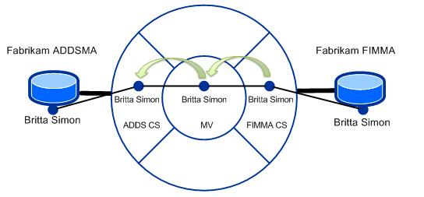

In this scenario, for a successfully synchronized object called Britta Simon, the following must be true:

1. A representation of Britta Simon must exist in the FIM service database
2. A representation of Britta Simon must be staged in the FIM connector space
3. The object in the FIM connector space must be linked to a representation of Britta Simon in the metaverse
4. The metaverse representation of Britta Simon must be linked to a representation in the AD DS connector space
5. A representation of Britta Simon must exist in AD DS.

To troubleshoot a generic synchronization error, you should compare your expected data flow with the actual data flow in your system.  
Your comparison should start at the beginning of the complete synchronization process.  
In the case of the current example, this is the representation of Britta Simon in the FIM service database.   
In addition to that you should map your expected data flow parts to the processing phases.  
This is necessary because your verification steps might be dependent on the processing phase.

In FIM, synchronizing identity data between external systems (**ES**) is the objective of the FIM synchronization service.  
The complete end-to-end process from a source to a target consists of three distinct phases:

1. **Import** – Identity data from an external system ES1 is staged in a connector space CS1
2. **Synchronization** – Identity data is synchronized between the connector spaces CS1 and CS2
3. **Export** – identity data that is staged in a connector space CS2 is exported to an external system ES2

The following illustration outlines the process flow in these phases:



In the case of a generic synchronization error, it is very unlikely for the error to be related to the import or export process.  
If something goes wrong in these phases, you will usually see a related error reported by the system in the Synchronization Service Manager.  
In other words, if an expected object does not appear in a target system, it is very likely that nothing was staged for an export in the target connector space.   
In this case, the export process has done what it is supposed to do.  
As a consequence of this, you can remove import and export from your troubleshooting related analysis and set the focus on the synchronization process.

The synchronization process from a source to a target involves a source connector space, the metaverse and at least one target connector space. Technically, the synchronization process consists of two distinct phases:

1. Inbound synchronization
2. Outbound synchronization

The objective of the inbound synchronization phase is to bring identity data that has been staged in a connector space (**CS**) into the metaverse (**MV**).  
When the inbound synchronization phase results in updates to the metaverse, the outbound synchronization phase is triggered.  
The following illustration outlines the related process flow:



You can use the architecture of the synchronization process to scope your troubleshooting analysis.   
For example, using the scenario outlined above, in which an object in the FIM service database is supposed to be provisioned to an AD DS, you should start your error analysis in the connector space of this FIM management agent and follow the data flow chain from the related source object to the connector space of the AD DS management agent.

Using the architecture of the synchronization process, you can draw the following conclusions:

1. If the required identity data does not appear in the connector space of the FIM management agent, you have an issue with the import process
2. If the required identity data does not appear in the metaverse, you have an issue with the inbound synchronization process
3. If the required identity data does not appear in the connector space of the ADDS management agent, you have an issue with the outbound synchronization process

As stated earlier in this document, it is very unlikely that you have a generic error issue with the import process, which means, you can focus your attention on the inbound and outbound synchronization process.

The second scoping level for your troubleshooting strategy is the part of the identity data that is missing.  
In other words, is you should scope your analysis based on whether a complete object or are attribute values are missing.  
When you are done scoping your issue, you are ready to use the tools that are available to troubleshoot your issue.

**Connector Space Search Feature**

In the case of the initialization of a scenario or in the case of a troubleshooting exercise, before you synchronize objects, you should first get an overview of what is staged in a source connector space.  
Next to CSExport, you can also use the Search Connector Space feature of the Synchronization Service Manager to do this.   
The Search Connector Space feature provides an option to limit the scope of the returned objects.   
For example, you can set the scope of a search to only return objects with a specific name or state.   
The following screenshot shows an example for the available scopes in the Search Connector Space dialog:

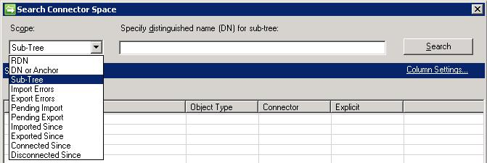

The search results are returned in form of a table with configurable column settings.  
The table view enables you to get an overview of the settings for a group of objects.  
Using Sub-Tree a scope without specifying a distinguished name (DN) returns all of the objects within the connector space.  
If you have many objects staged in your connector space, you can reduce the amount of returned data by specifying a scope.

The following screenshot shows an example for the results returned by a connector space search:

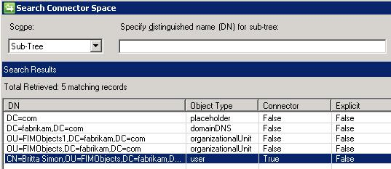

More details about a result can be obtained by double-clicking the result:

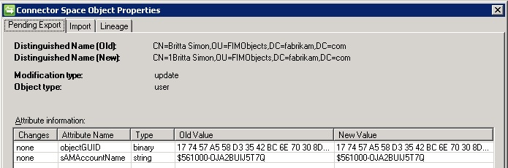

The connector space search result returns:

* The attribute values of a connector space object.
* Important state information regarding the synchronization process.
* The metaverse object the connector space object is linked to.

In other words, you can use the connector space object properties to troubleshoot synchronization process related issues.

**Metaverse Search Feature**

The metaverse search feature is similar to the connector space search.   
The main difference is the perspective used to look at your identity data.   
For a metaverse search, the entry point is a metaverse object.  
The objects returned by a metaverse search include information about the connector space objects a metaverse object is linked to as well as the method that was used to establish the connection:

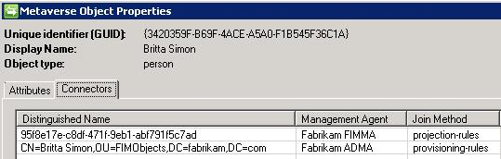

**Tools to analyze the synchronization process**

Verifying your configuration is the first step to detect configuration mistakes.  
However, this does not always help to find the error.  
In this case, you can either initiate a test synchronization run for a specific object or you can analyze the reported statistics of an actual synchronization run  
For both methods to work, you should always start with an expectation.  
For example, if you plan to synchronize 100 new objects from a source to a target, you should review the reported values and compare them with your expectation.  
As a best practice, you should write your expectation and the reported values down.   
When you use the related tools to analyze the synchronization process, you should always keep the architecture of the synchronization process in mind:



The available tools to analyze the synchronization process are structured in a way that provides the related information in alignment with this process.

To provide information about the synchronization process, FIM provides the following tools:

1. Management Agent Statistics
2. Synchronization Statistics
3. Synchronization Process Preview

**Management Agent Statistics**

The management agent statistics dialog of the Synchronization Service Manager gives you a high level report about the data that has been staged in the connector space of an object.  
This data gives you a first impression about the health of a connector space.  
For example, if the number of disconnecters is high you might have an issue with your inbound synchronization rule.

The following screenshot shows an example of the management agent statistics:

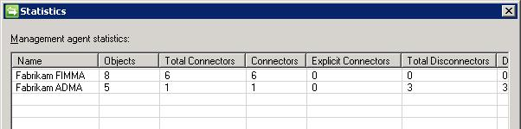

**Synchronization Statistics**

When you run a run profile, you can use the Synchronization Statistics in the user interface of the Synchronization Service Manager to retrieve processing information.  
Reported updates are indicated in form of a link you can use to review the affected objects.   
The following screenshot shows an example of the reported statistics for a delta import synchronization run:

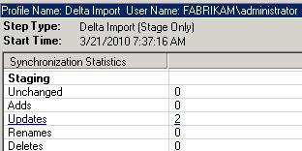

Synchronization statistics are grouped according to the architecture of the synchronization process into inbound and outbound synchronization.   
While inbound synchronization has always one connector space as source and the metaverse as target, outbound synchronization statistics have to be grouped by target connector spaces.   
The following screenshot shows an example for the synchronization statistics of a synchronization run:

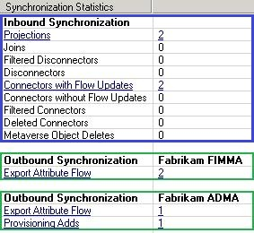

**Synchronization Process Preview**

In the Synchronization Service Manager, you can get information about the current state of your objects and you can also use it to simulate (“what if”) a synchronization run for an object.  
In the FIM terminology, this is also known as preview.   
All dialogs that are displaying connector space object details provide the option to run a preview.   
This includes, for example, the Search Connector Space feature that was introduced in a previous section.

To launch the Preview dialog, you click the Preview button on the properties dialog page of a connector space object:

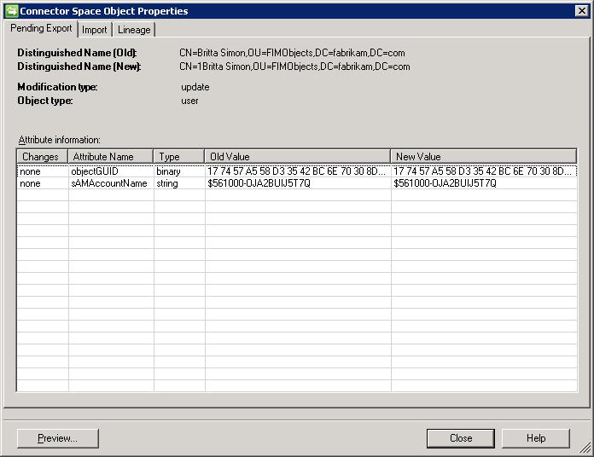

During a preview run, your synchronization rules are applied to the selected object and the processing results are displayed.   
The following screenshot shows an example for this:

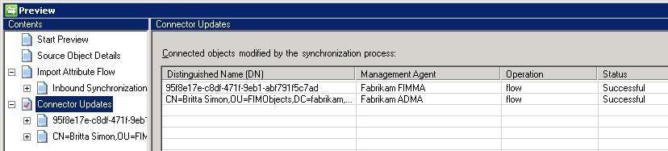

The option to apply your synchronization rules to an object makes the preview feature a very powerful tool in the troubleshooting process.

**Attribute Flow Precedence Configuration Verification**

During the synchronization process, alleged data loss can also be a result of your attribute flow precedence configuration.   
The attribute flow precedence process determines whether a source is granted permission to flow an attribute value to a target.   
If the source does not have a sufficient precedence value, the precedence process rejects an attempt to flow an attribute value.   
The following illustration outlines how this process works:

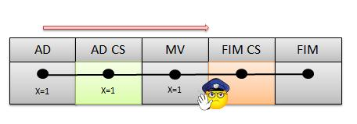

An attribute flow precedence check is applied during inbound and outbound attribute flows. The best method to detect attribute flow precedence related issues is using the preview feature. When the flow precedence process rejects an attribute flow, you will find a skipped not precedent status for the related flow. The following screenshot shows an example for this:

example for this:

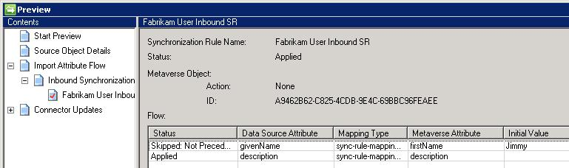

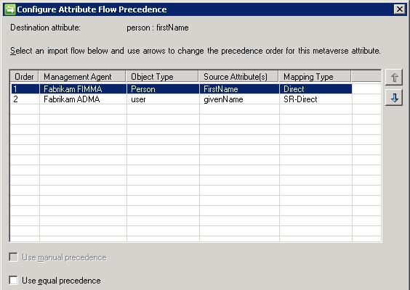

**Summary**

Troubleshooting generic synchronization errors is not that difficult if you are familiar with the synchronization process and its components.  
It is important to start at the right place with your analysis.  
The right place is the source connector space of your object.  
From the source connector space, you follow the processing chain through the metaverse to the target connector space.   
By using the related search tool such as connector space and metaverse search, you examine the attributes and the connection state of the affected object to determine what the issue is.  
If analyzing the current state of the objects doesn’t provide the required information to solve the issue, you should run synchronization in preview mode, which will tell you how the synchronization service would process the objects.

Key for your analysis is to write down your expectations first, and then to compare them with your actual results. Recording your troubleshooting steps is helpful – even if you can’t solve the issue.  
You can use the data in a post to the FIM forum or when you contact PSS to speed up the troubleshooting process.  
In many cases, it is advisable to also include a report of your current configuration.

### ATTRIBUTE FLOW PRECEDENCE

The flowing section comes from the technet forum below:

<http://social.technet.microsoft.com/Forums/en-US/identitylifecyclemanager/thread/2c4f5c39-de0b-4fed-9cdd-057d0394085b>

Very often we think of precedence in terms of authoritative sources: the repository where the lifecycle of an object begins and from where the major changes are triggered.   
However, this is not the only source of authority: also for individual attributes authority can be defined, or, as it is called in ILM speak, “*attribute precedence*”.

On the way from the connector space of a connected system to the metaverse, there are two gates that must be passed.   
The first gate is implemented in the form of an import attribute flow rule.   
However, when an attribute has passed this gate, it also needs to pass the next gate – the attribute flow precedence, as illustrated in the following picture:

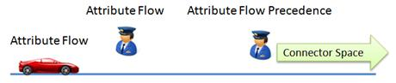

The fact that there are actually two gates that govern on the import flow side and on the export flow side how and whether attributes flow to and out of the metaverse, is a fact people tend to forget when working with ILM.

This is why I’m writing this article.

Precedence defined

When multiple **management agents (MAs)** define an **import attribute flow (IAF)** for the same **metaverse (MV)** attribute of a single object, ILM needs a way to decide which of these IAFs wins.  
By default, the flow that is defined first is the one that wins.

Obviously, this default flow may not be the one that you would want to win.  
Therefore, for this kind of flow, attribute precedence, or precedence needs to be defined.  
Precedence is defined on a per attribute basis for each of the objects for which the attribute is available and is configured in the MV designer tool.

Precedence is applied both for import and export attribute flows.  
The reason for precedence on IAF has been indicated above.  
For **export attributes flows (EAFs)**, precedence rules are needed in order to avoid that values of attributes coming from connected data sources with lower precedence flow to connected data sources with higher precedence, possibly leading to unwanted data loss.

Logically, ILM stores a value in the MV like this: *Attribute Name, Attribute Value, Precedence of contributor*

So, let’s imagine that for a given attribute X, we have 3 possible contributing MA’s, in order of precedence:

* 1. HR MA
  2. AD MA
  3. File MA

Practically, File MA can contribute a value to the MV as long as the attribute has not been populated yet.

If ADMA has a value, it can contribute the value at which point values from File MA are blocked.  
In the same way, as soon as HR MA contributes a value, the AD MA (and File MA) is blocked from contributing.

So, there is a little “game” (show me your precedence and I tell you whether you can contribute) going on and I don’t think that many folks are aware of how this works.

One last thing to remember is that precedence rules for attributes are defined on an object by object basis.   
So, if given an attribute x that is available for object types y and z, then precedence for that attribute needs to be defined for both object types (of course when multiple flows are defined for that particular object-attribute pair).

Implementing precedence

As it turns out, precedence comes in two shapes: in many cases you can define a fixed order of precedence.   
This fixed order can easily be implemented using the MV Designer tool in Identity Manager.

You can use the following procedure to configure attribute flow precedence:

* 1. In ILM, open Identity Manager.
  2. Switch to the Metaverse Designer view.
  3. In the Object types list, select the object type for which attribute(s) you need to change the attribute precedence (e.g. person)
  4. For each attribute that has multiple IAFs, complete the following steps:
     1. Select the attribute from the Attributes list.
     2. To open the Configure Attribute Flow Precedence dialog box, click Configure Attribute Flow Precedence on the Actions menu.
     3. In the Management Agents list, use the up and down arrows to change the precedence order of the MAs in the list. Higher up the list means precedent over lower down the list.

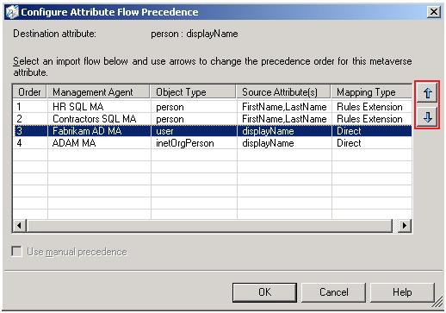

* + 1. To close the Configure Attribute Flow Precedence dialog box, click OK.

When the previous method is not sufficient and you need more flexibility, e.g. because your rule needs to depend on the value of an attribute, you can implement what is called manual precedence.  
When you define manual precedence for an attribute, the default precedence evaluation is switched off.

Since the default precedence evaluation rules are switched off, the implementer will need to supply his own (in code).  
Therefore, ILM will only allow you to switch on manual precedence when all IAFs for a given attribute are defined as advanced flows.   
In Figure 1 above, the check box “*Use manual precedence*” is disabled (and unchecked) as two of the four mapping types are of type Direct.   
As soon as these two mappings are implemented in code, precedence could be switched to manual (if required by the scenario implemented of course).

For completeness, ILM’s successor, **Forefront Identity Manager 2010 (FIM)**, defines a third kind of precedence called **equal precedence**.   
You configure *equal precedence* when you want to remove attribute precedence for a certain MV attribute.   
As a net effect, when the MV attribute is multi-valued, all values contributed by the different MAs are accumulated in the MV attribute.   
When the MV attribute is single valued, the value that is last contributed is stored in the MV attribute, or, “*the last writer wins*”.

For some scenarios it is possible to also implement equal precedence in an ILM 2007 system – a notoriously impossible scenario however is an equal precedence scenario involving multi-valued reference attributes (such as e.g. members of groups – a scenario where FIM shines). For the scenarios where implementing equal precedence in ILM is possible, precedence will need to be done completely in code. However, your flow code would not have anything that is precedence related.

Common Problems

In this section, I will outline some common problems in conjunction with attribute flow precedence.

**Missing or wrong data on export**

A common attribute flow precedence issue is a result of adding a new management agent. When adding a new management agent, ILM administrators often only focus on the attribute flow rules.   
What they often forget to verify is whether the newly added flow rules have the required attribute flow precedence to produce the desired results.   
Good to know is that existing flows have higher precedence than the new flows defined.

This same error will of course also occur when you simply forget about defining precedence.

When defining IAFs, you always need to keep in mind that after the synchronization engine looks at your IAF and determines that work needs to be done (because of a pending import), it will also look at the defined precedence (whether forgotten or not).

When implementing a new MA, I recommend checking your attribute flow precedence configuration.   
Verify in the MV designer for each object, whether a newly added flow has the required precedence.   
The easiest way to do this is to simply sort the attributes on the number of import flows defined to get those attributes to the top of the list that have multiple IAFs, as shown in the following screenshot:

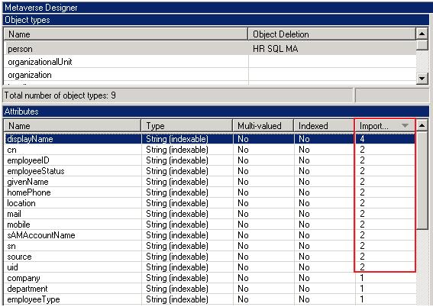

**Export Precedence**

More complex is a second common problem, related to the dreaded “*Skipped: Not Precedent*” message on Export Attribute Flows (EAFs).  
The following screenshot shows an example for this.

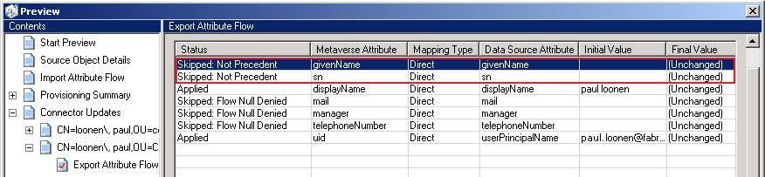

As already stated in the introduction, it is a little known fact that precedence rules also have their impact on EAFs.   
The synchronization engine applies an attribute flow precedence check also for EAFs.   
This is necessary to avoid that attribute values coming from a data source with a lower precedence flow to a target with a higher precedence.   
Without this check, unwanted data loss is possible.   
As a consequence, these rules do not apply when defining manual precedence, or when there is no source attribute (e.g. when flowing a constant value into the MV).

In general, you will get into this situation when for a given MA you define both an IAF and an EAF for an attribute, so flowing a value from the CS into the MV and flowing it back into the same CS.

A simple case is illustrated in the following picture.

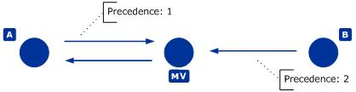

In this case, when B contributes to the MV, the value won’t flow to A as the precedence of A is higher.

This rule also applies when an advanced flow, possibly combining multiple attributes, contributes the value in the MV, as illustrated in the following picture (A and C are different attributes of the same object):

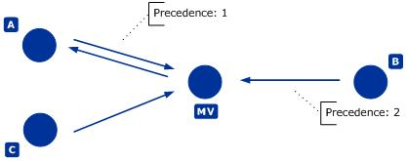

**Ambiguous Import Flows**

Another problem that you may encounter when implementing attribute flows is the “*ambiguous-import-flow-from-multiple-connectors*” error problem.   
This error is a result of having multiple connectors coming from the same CS for the same object in the MV.   
The error is illustrated in following screenshot.

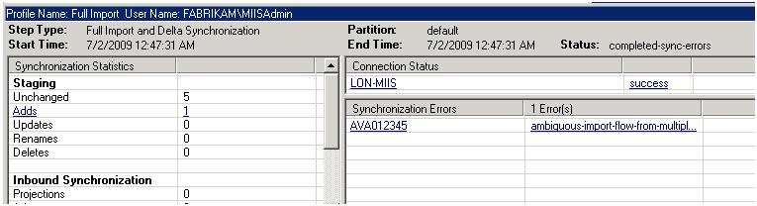

Clicking on the “*AVA012345*” hyperlink in the previous screenshot and clicking on the “*preview*” button in the dialog box that appears reveals the following after clicking on “*Generate Preview*”:

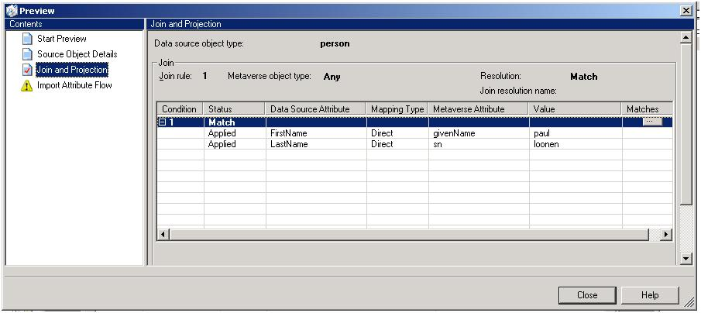

Clicking the “*…*” button in the previous screenshot will lead you to the MV object that your object would like to be joined to.   
On the MV object you can then examine the list of connectors, where you will find that there already is a connector for your CS:

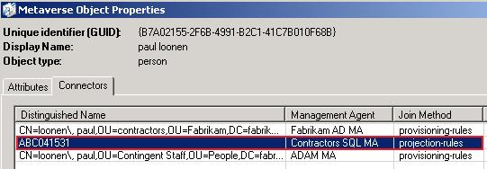

Which now leads to the question, how do I solve this problem and allow the CS object to join to the MV object in question.   
In the example above, having multiple connectors from the same CS, was probably not intended.  
The issue is a result of the configured join rule, which links objects with matching first name and last name attribute values.   
With this configuration, all objects with the same first name and last name attribute values will join to a single metaverse object. However, you should only join objects that are a representation of the same physical identity to a metaverse object.   
To identify an identity, a first name last name combination is inefficient.   
You can address this issue by adding additional join criteria such as a birth date. However, this is also just a quick fix.  
The ideal join criterion consists of a Correlation ID. You can find more details on this in the [Design Concepts for Correlating Digital Identities](http://download.microsoft.com/download/c/b/3/cb3e8ab9-d892-442e-b16a-51b54509fdc8/CorrelationID.doc).

There are cases, where you actually do have multiple representations of the same physical identity in a connector space.   
For example, a common best practice for system administrators is to use the administrative account only to perform administrative tasks.   
All system administrator should also have a regular user account to perform non administrative tasks in a network.  
If the best practice is implemented, you have a scenario where a physical identity can have multiple accounts in an environment that need to be aggregated to one metaverse object.   
In this scenario, you need to convert all offending import attribute flows as advanced flows in a related rules extension.